UNITED STATES
SECURITIES AND EXCHANGE COMMISSION
WASHINGTON, D.C. 20549
FORM 6-K
REPORT OF FOREIGN PRIVATE ISSUER
PURSUANT TO RULE 13a-16 OR 15d-16 UNDER
THE SECURITIES EXCHANGE ACT OF 1934
For the month of August 2026

Commission File Number: 001-39173

NovaBridge Biosciences
2440 Research Boulevard, Suite 400
Rockville, MD 20850
(Address of principal executive offices)
Indicate by check mark whether the registrant files or will file annual reports under cover of Form 20-F or Form 40-F.
Form 20-F ☒ Form 40-F ☐

On August 20, 2026, NovaBridge Biosciences issued an investor presentation, a copy of which is furnished herewith as Exhibit 99.1.

EXHIBIT INDEX

Exhibit No. | Description
99.1 | Investor Presentation - August 20, 2026

SIGNATURES
Pursuant to the requirements of the Securities Exchange Act of 1934, the registrant has duly caused this report to be signed on its behalf by the undersigned, thereunto duly authorized.

 | NovaBridge Biosciences
 | By | : | /s/ Kyler Lei
 | Name | : | Kyler Lei
 | Title | : | Chief Financial Officer

Date: August 20, 2026

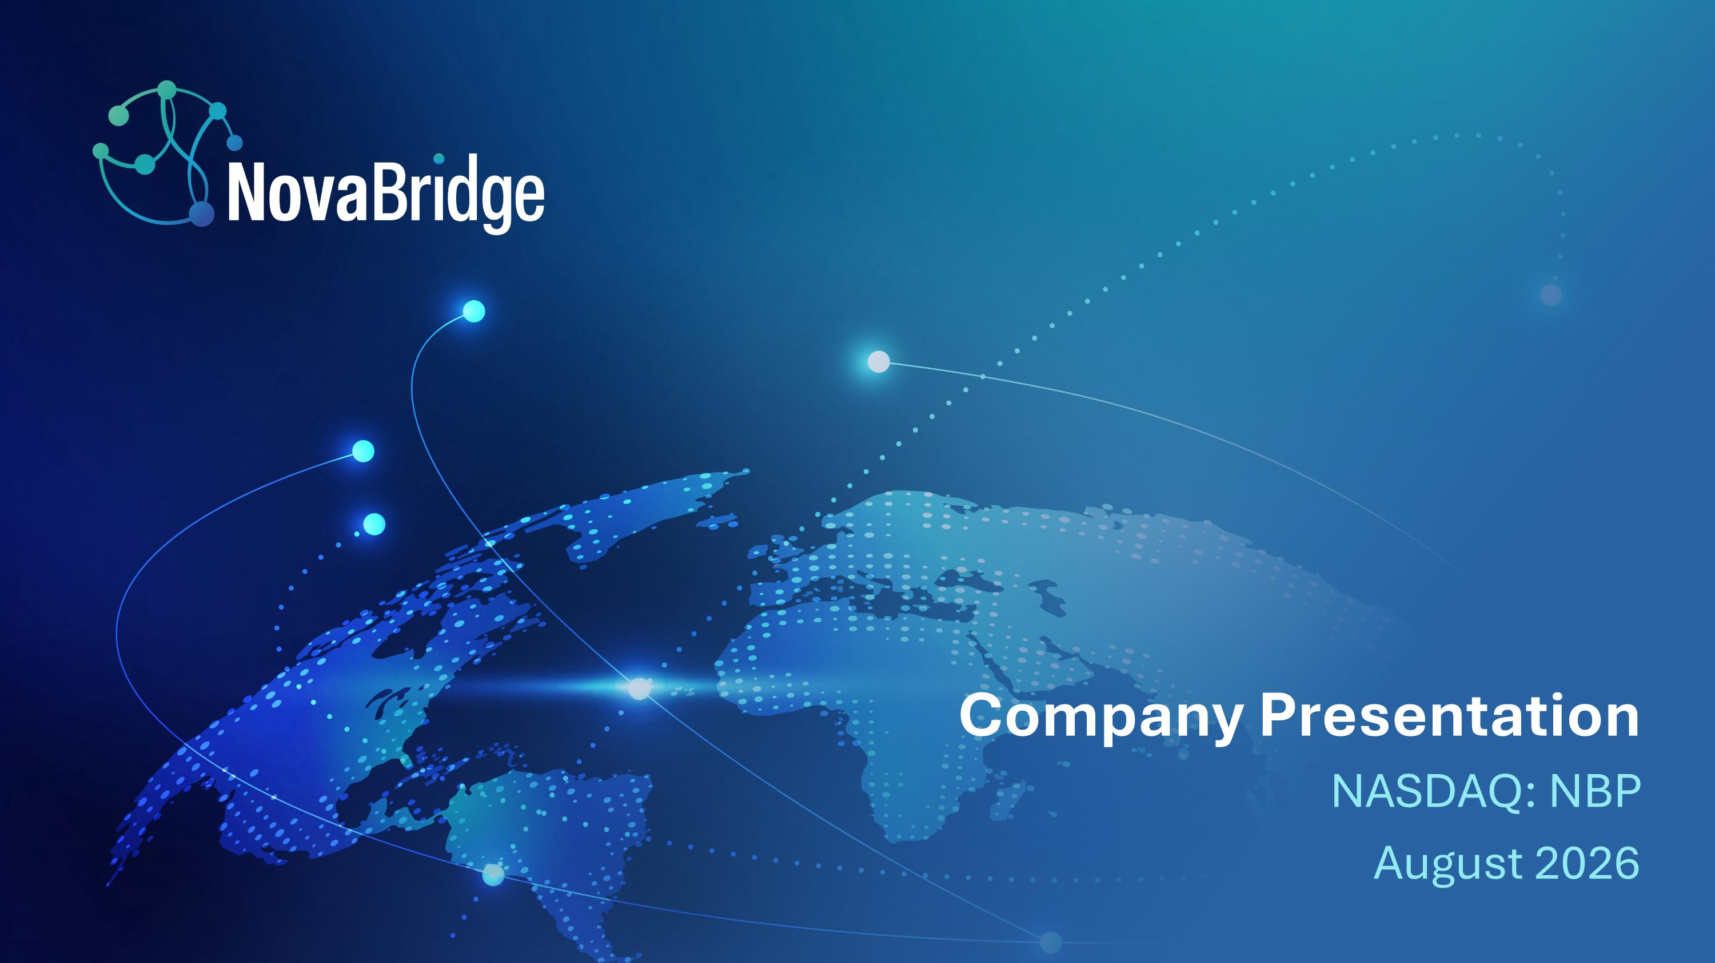
Company Presentation NASDAQ: NBP August 2026

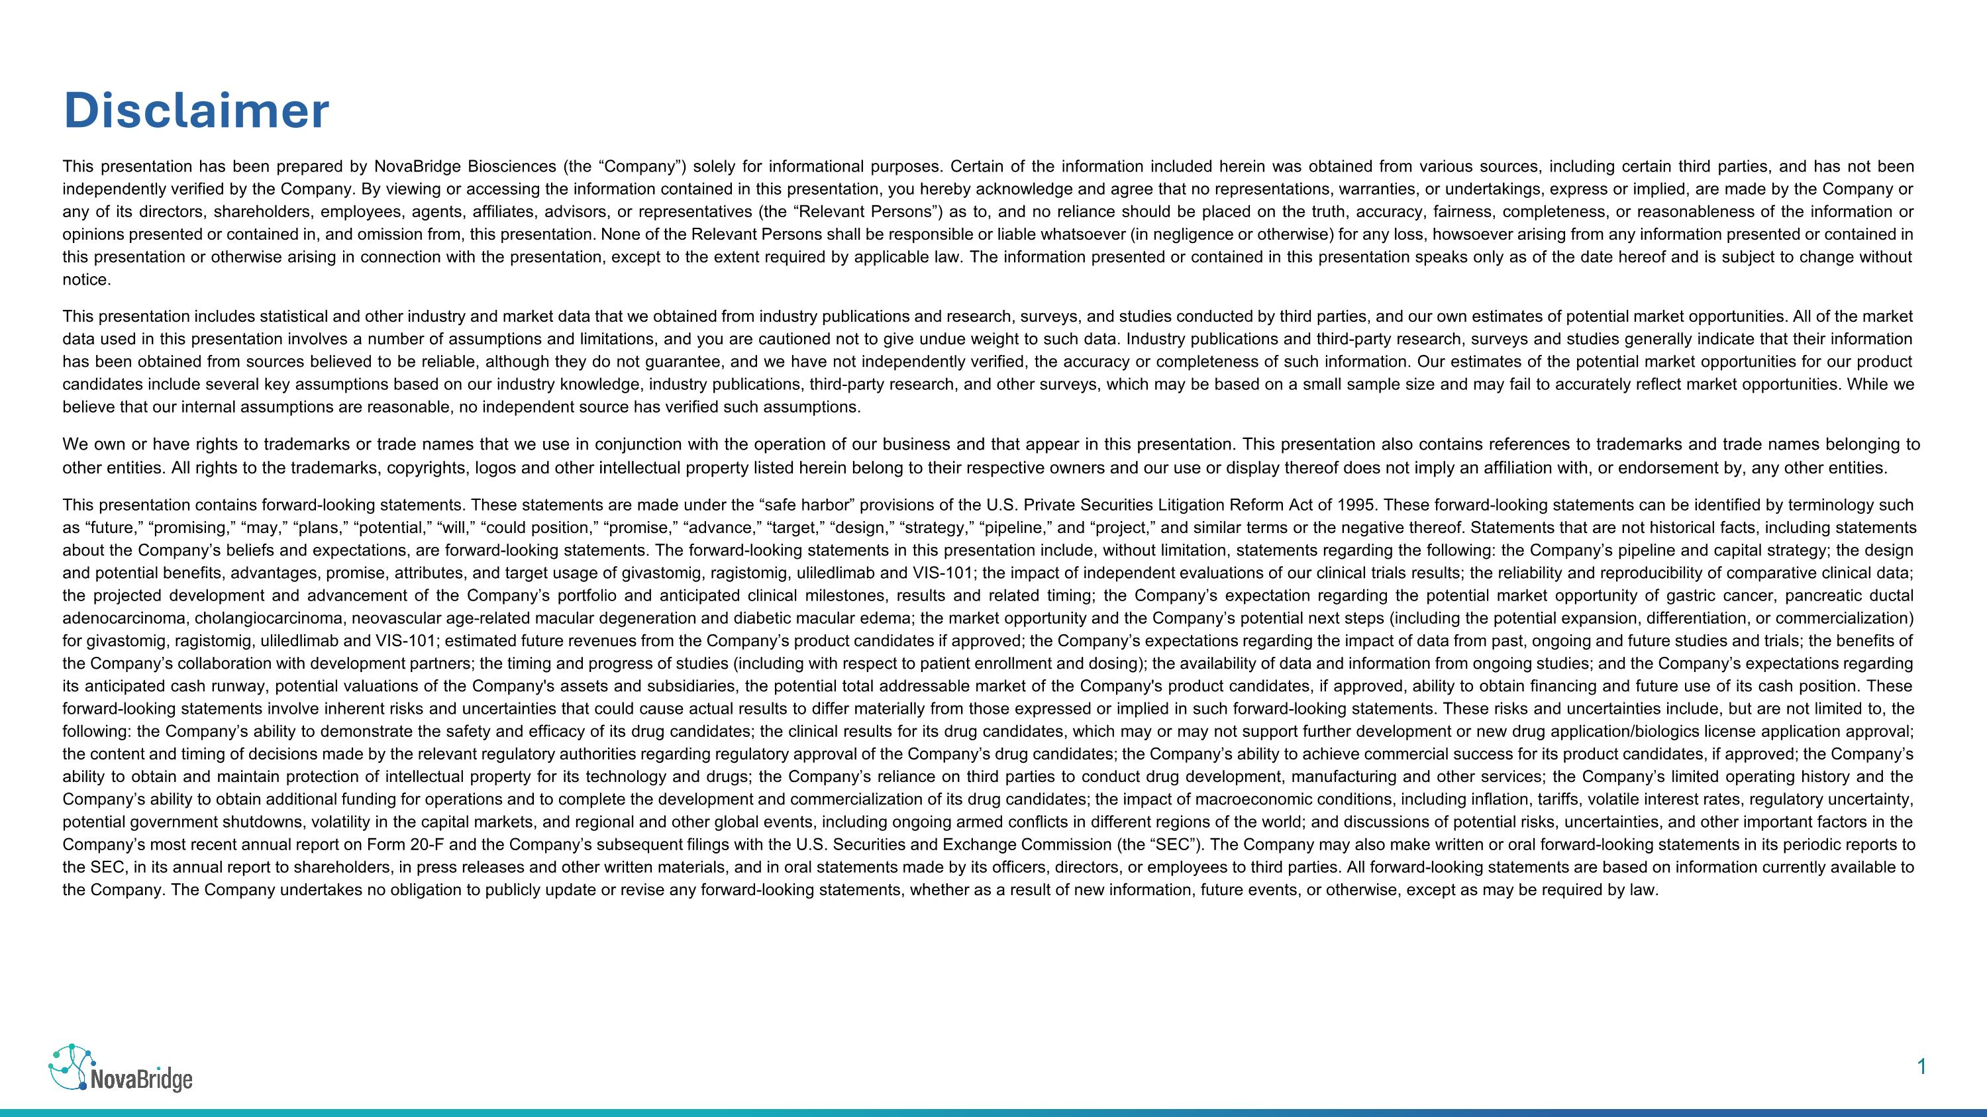
Disclaimer This presentation has been prepared by NovaBridge Biosciences (the “Company”) solely for informational purposes. Certain of the information included herein was obtained from various sources, including certain third parties, and has not been independently verified by the Company. By viewing or accessing the information contained in this presentation, you hereby acknowledge and agree that no representations, warranties, or undertakings, express or implied, are made by the Company or any of its directors, shareholders, employees, agents, affiliates, advisors, or representatives (the “Relevant Persons”) as to, and no reliance should be placed on the truth, accuracy, fairness, completeness, or reasonableness of the information or opinions presented or contained in, and omission from, this presentation. None of the Relevant Persons shall be responsible or liable whatsoever (in negligence or otherwise) for any loss, howsoever arising from any information presented or contained in this presentation or otherwise arising in connection with the presentation, except to the extent required by applicable law. The information presented or contained in this presentation speaks only as of the date hereof and is subject to change without notice. This presentation includes statistical and other industry and market data that we obtained from industry publications and research, surveys, and studies conducted by third parties, and our own estimates of potential market opportunities. All of the market data used in this presentation involves a number of assumptions and limitations, and you are cautioned not to give undue weight to such data. Industry publications and third-party research, surveys and studies generally indicate that their information has been obtained from sources believed to be reliable, although they do not guarantee, and we have not independently verified, the accuracy or completeness of such information. Our estimates of the potential market opportunities for our product candidates include several key assumptions based on our industry knowledge, industry publications, third-party research, and other surveys, which may be based on a small sample size and may fail to accurately reflect market opportunities. While we believe that our internal assumptions are reasonable, no independent source has verified such assumptions. We own or have rights to trademarks or trade names that we use in conjunction with the operation of our business and that appear in this presentation. This presentation also contains references to trademarks and trade names belonging to other entities. All rights to the trademarks, copyrights, logos and other intellectual property listed herein belong to their respective owners and our use or display thereof does not imply an affiliation with, or endorsement by, any other entities. This presentation contains forward-looking statements. These statements are made under the “safe harbor” provisions of the U.S. Private Securities Litigation Reform Act of 1995. These forward-looking statements can be identified by terminology such as “future,” “promising,” “may,” “plans,” “potential,” “will,” “could position,” “promise,” “advance,” “target,” “design,” “strategy,” “pipeline,” and “project,” and similar terms or the negative thereof. Statements that are not historical facts, including statements about the Company’s beliefs and expectations, are forward-looking statements. The forward-looking statements in this presentation include, without limitation, statements regarding the following: the Company’s pipeline and capital strategy; the design and potential benefits, advantages, promise, attributes, and target usage of givastomig, ragistomig, uliledlimab and VIS-101; the impact of independent evaluations of our clinical trials results; the reliability and reproducibility of comparative clinical data; the projected development and advancement of the Company’s portfolio and anticipated clinical milestones, results and related timing; the Company’s expectation regarding the potential market opportunity of gastric cancer, pancreatic ductal adenocarcinoma, cholangiocarcinoma, neovascular age-related macular degeneration and diabetic macular edema; the market opportunity and the Company’s potential next steps (including the potential expansion, differentiation, or commercialization) for givastomig, ragistomig, uliledlimab and VIS-101; estimated future revenues from the Company’s product candidates if approved; the Company’s expectations regarding the impact of data from past, ongoing and future studies and trials; the benefits of the Company’s collaboration with development partners; the timing and progress of studies (including with respect to patient enrollment and dosing); the availability of data and information from ongoing studies; and the Company’s expectations regarding its anticipated cash runway, potential valuations of the Company's assets and subsidiaries, the potential total addressable market of the Company's product candidates, if approved, ability to obtain financing and future use of its cash position. These forward-looking statements involve inherent risks and uncertainties that could cause actual results to differ materially from those expressed or implied in such forward-looking statements. These risks and uncertainties include, but are not limited to, the following: the Company’s ability to demonstrate the safety and efficacy of its drug candidates; the clinical results for its drug candidates, which may or may not support further development or new drug application/biologics license application approval; the content and timing of decisions made by the relevant regulatory authorities regarding regulatory approval of the Company’s drug candidates; the Company’s ability to achieve commercial success for its product candidates, if approved; the Company’s ability to obtain and maintain protection of intellectual property for its technology and drugs; the Company’s reliance on third parties to conduct drug development, manufacturing and other services; the Company’s limited operating history and the Company’s ability to obtain additional funding for operations and to complete the development and commercialization of its drug candidates; the impact of macroeconomic conditions, including inflation, tariffs, volatile interest rates, regulatory uncertainty, potential government shutdowns, volatility in the capital markets, and regional and other global events, including ongoing armed conflicts in different regions of the world; and discussions of potential risks, uncertainties, and other important factors in the Company’s most recent annual report on Form 20-F and the Company’s subsequent filings with the U.S. Securities and Exchange Commission (the “SEC”). The Company may also make written or oral forward-looking statements in its periodic reports to the SEC, in its annual report to shareholders, in press releases and other written materials, and in oral statements made by its officers, directors, or employees to third parties. All forward-looking statements are based on information currently available to the Company. The Company undertakes no obligation to publicly update or revise any forward-looking statements, whether as a result of new information, future events, or otherwise, except as may be required by law.

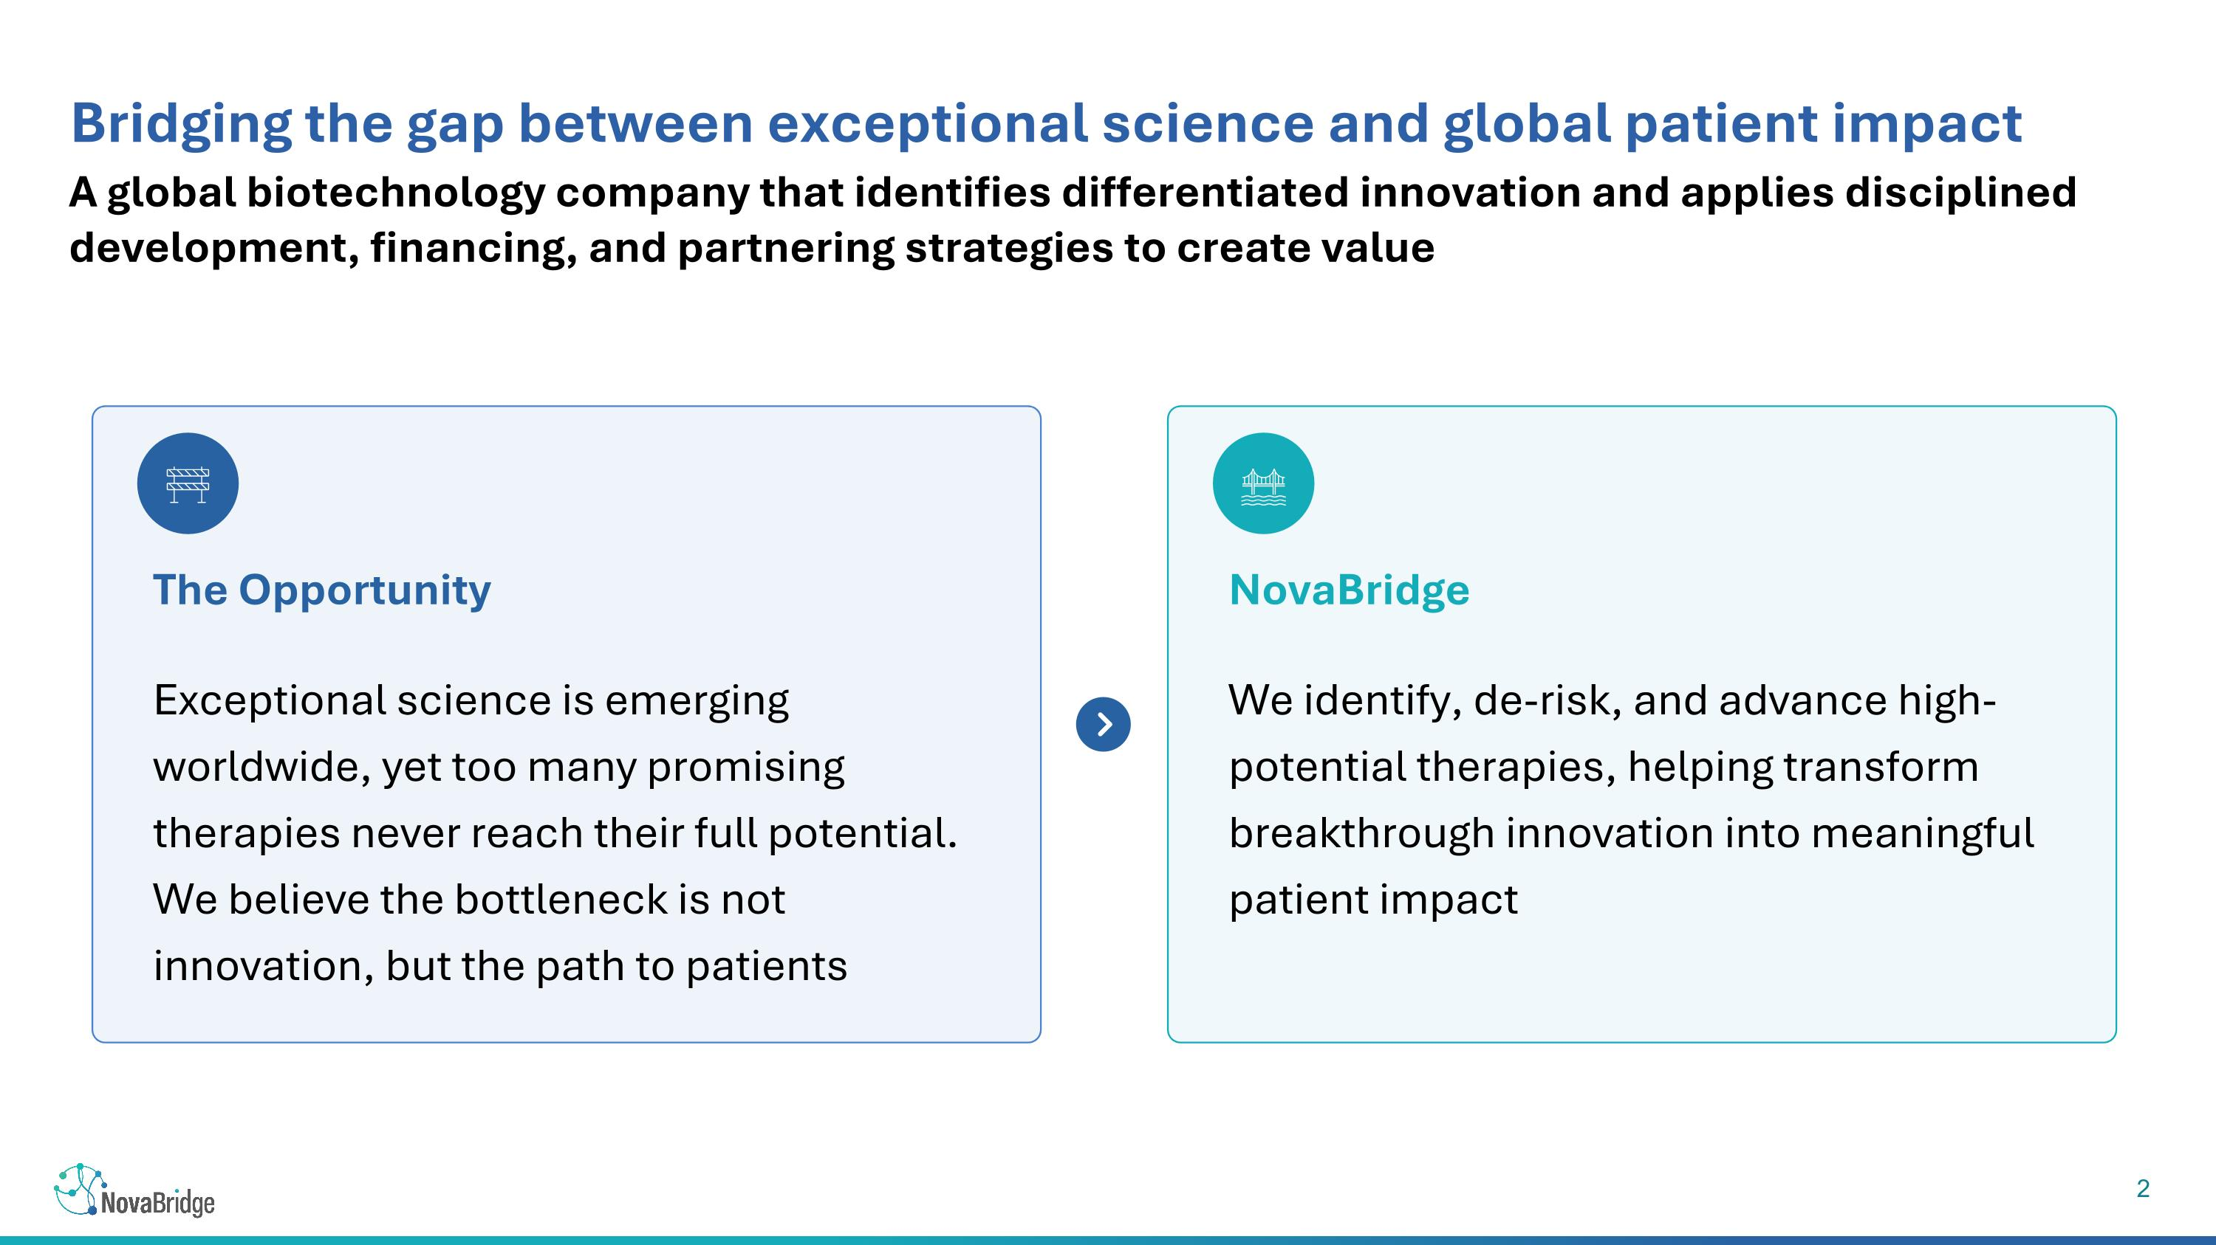
A global biotechnology company that identifies differentiated innovation and applies disciplined development, financing, and partnering strategies to create value Bridging the gap between exceptional science and global patient impact Exceptional science is emerging worldwide, yet too many promising therapies never reach their full potential. We believe the bottleneck is not innovation, but the path to patients The Opportunity We identify, de-risk, and advance high-potential therapies, helping transform breakthrough innovation into meaningful patient impact NovaBridge

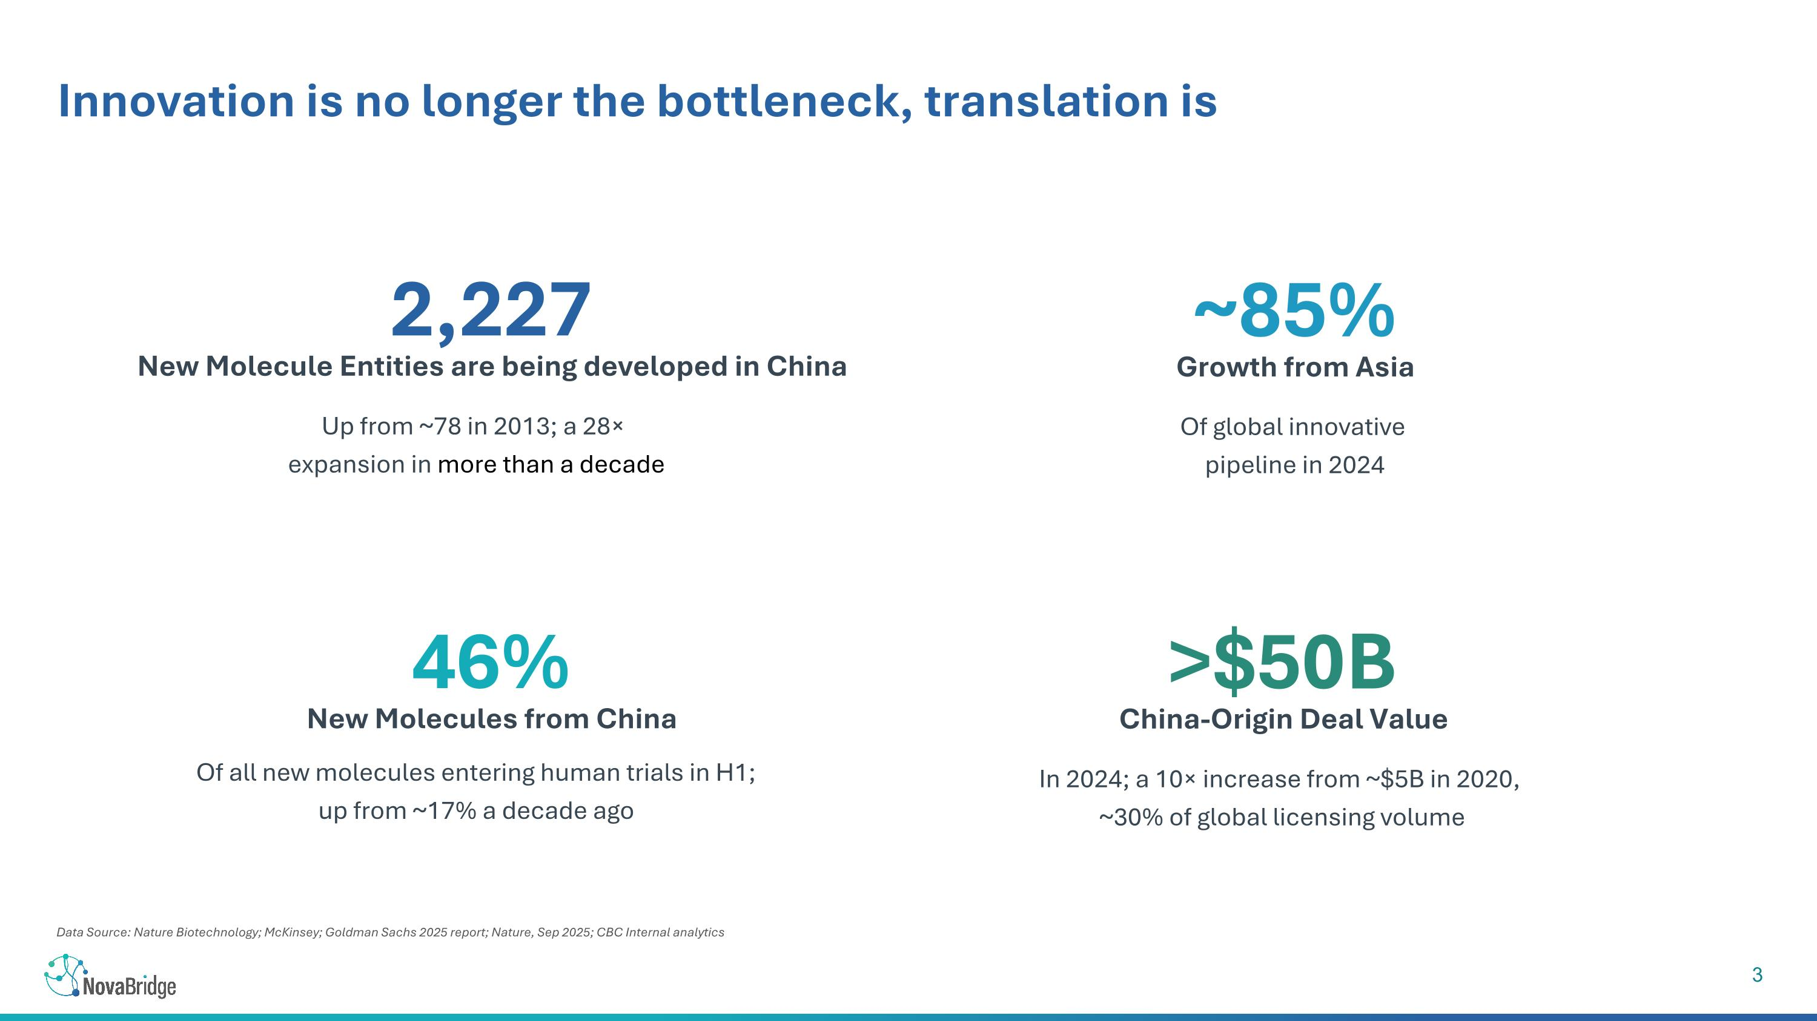
Data Source: Nature Biotechnology; McKinsey; Goldman Sachs 2025 report; Nature, Sep 2025; CBC Internal analytics Innovation is no longer the bottleneck, translation is 2,227 New Molecule Entities are being developed in China Up from ~78 in 2013; a 28× expansion in more than a decade ~85% Growth from Asia 46% New Molecules from China Of all new molecules entering human trials in H1; ?up from ~17% a decade ago >$50B China-Origin Deal Value In 2024; a 10× increase from ~$5B in 2020, ~30% of global licensing volume Of global innovative pipeline in 2024

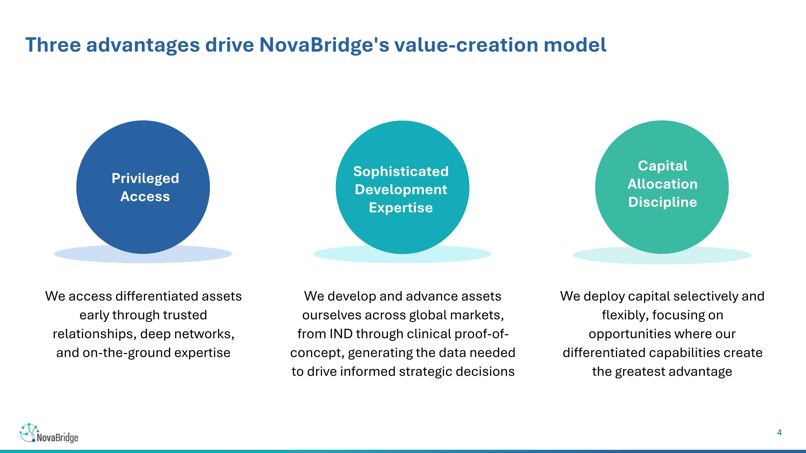
We access differentiated assets early through trusted relationships, deep networks, and on-the-ground expertise Privileged Access We develop and advance assets ourselves across global markets, from IND through clinical proof-of-concept, generating the data needed to drive informed strategic decisions Sophisticated Development Expertise We deploy capital selectively and flexibly, focusing on opportunities where our differentiated capabilities create the greatest advantage Capital Allocation Discipline Three advantages drive NovaBridge's value-creation model

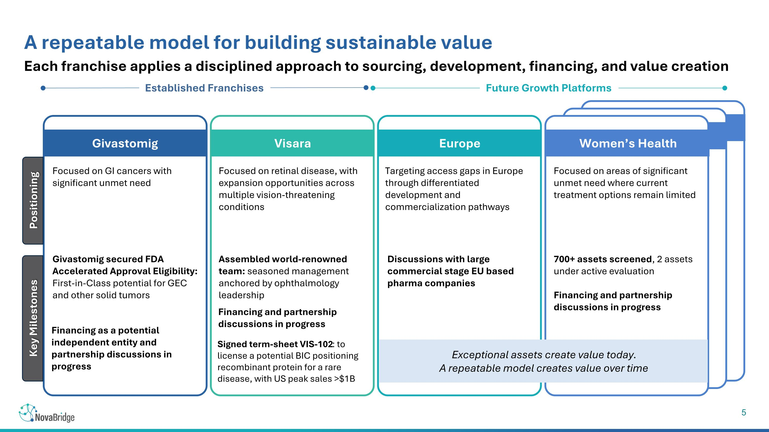
Each franchise applies a disciplined approach to sourcing, development, financing, and value creation Established Franchises Future Growth Platforms A repeatable model for building sustainable value Givastomig secured FDA Accelerated Approval Eligibility: First-in-Class potential for GEC and other solid tumors Financing and partnership discussions in progress Focused on GI cancers with significant unmet need Focused on retinal disease, with expansion opportunities across multiple vision-threatening conditions Targeting access gaps in Europe through differentiated development and commercialization pathways Assembled world-renowned team: seasoned management anchored by ophthalmology leadership Focused on areas of significant unmet need where current treatment options remain limited Exceptional assets create value today. A repeatable model creates value over time Discussions with large commercial stage EU based pharma companies 700+ assets screened, 2 assets under active evaluation Financing and partnership discussions in progress Financing as a potential independent entity and partnership discussions in progress Givastomig Visara Europe Women’s Health Positioning Key Milestones Signed term-sheet VIS-102: to license a potential BIC positioning recombinant protein for a rare disease, with US peak sales >$1B

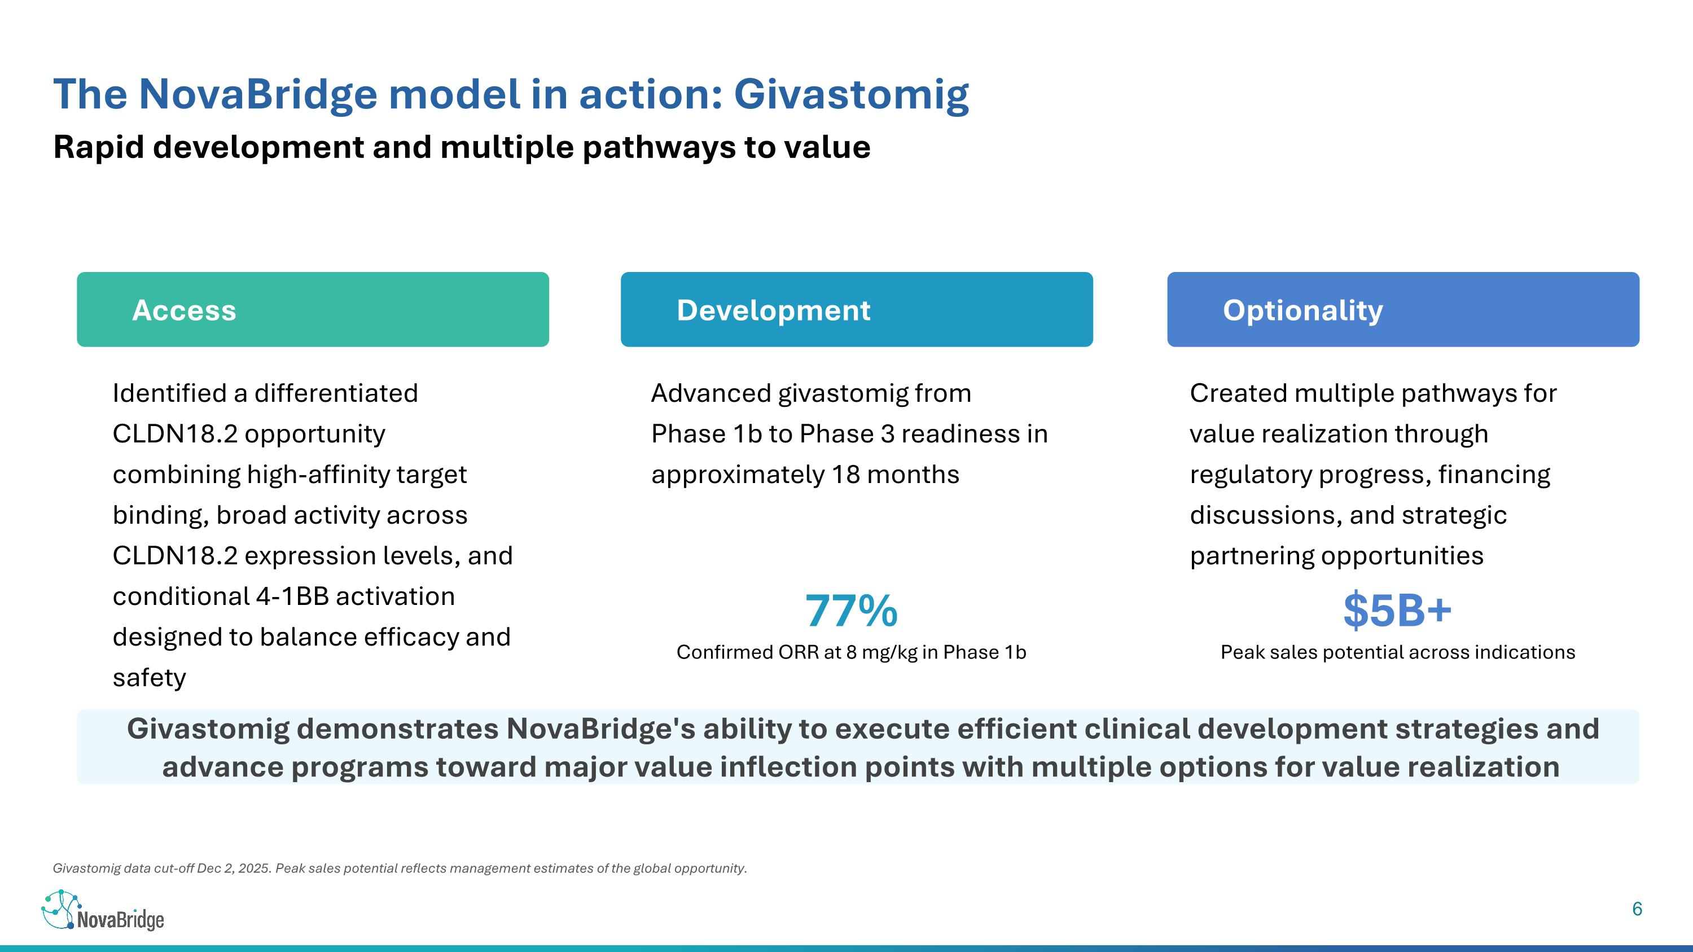
Givastomig data cut-off Dec 2, 2025. Peak sales potential reflects management estimates of the global opportunity. Rapid development and multiple pathways to value The NovaBridge model in action: Givastomig Access Identified a differentiated CLDN18.2 opportunity combining high-affinity target binding, broad activity across CLDN18.2 expression levels, and conditional 4-1BB activation designed to balance efficacy and safety Development Advanced givastomig from Phase 1b to Phase 3 readiness in approximately 18 months Optionality Created multiple pathways for value realization through regulatory progress, financing discussions, and strategic partnering opportunities 77% Confirmed ORR at 8 mg/kg in Phase 1b $5B+ Peak sales potential across indications Givastomig demonstrates NovaBridge's ability to execute efficient clinical development strategies and advance programs toward major value inflection points with multiple options for value realization

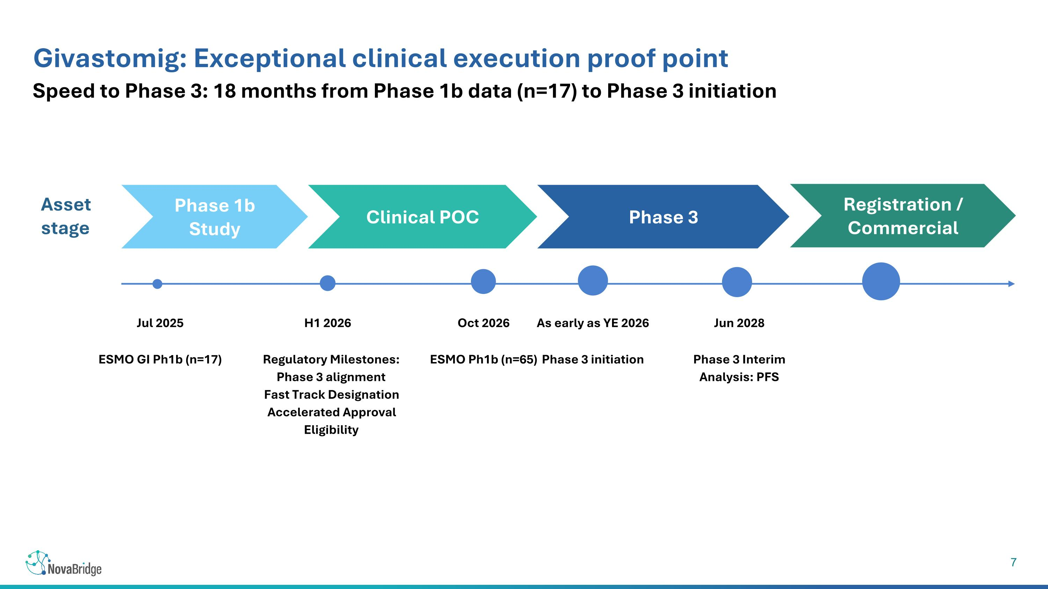
Speed to Phase 3: 18 months from Phase 1b data (n=17) to Phase 3 initiation Givastomig: Exceptional clinical execution proof point Asset stage Jul 2025 ESMO GI Ph1b (n=17) H1 2026 Regulatory Milestones: Phase 3 alignment Fast Track Designation Accelerated Approval Eligibility Oct 2026 ESMO Ph1b (n=65) As early as YE 2026 Phase 3 initiation Jun 2028 Phase 3 Interim Analysis: PFS Phase 1b Study Clinical POC Phase 3 Registration / Commercial

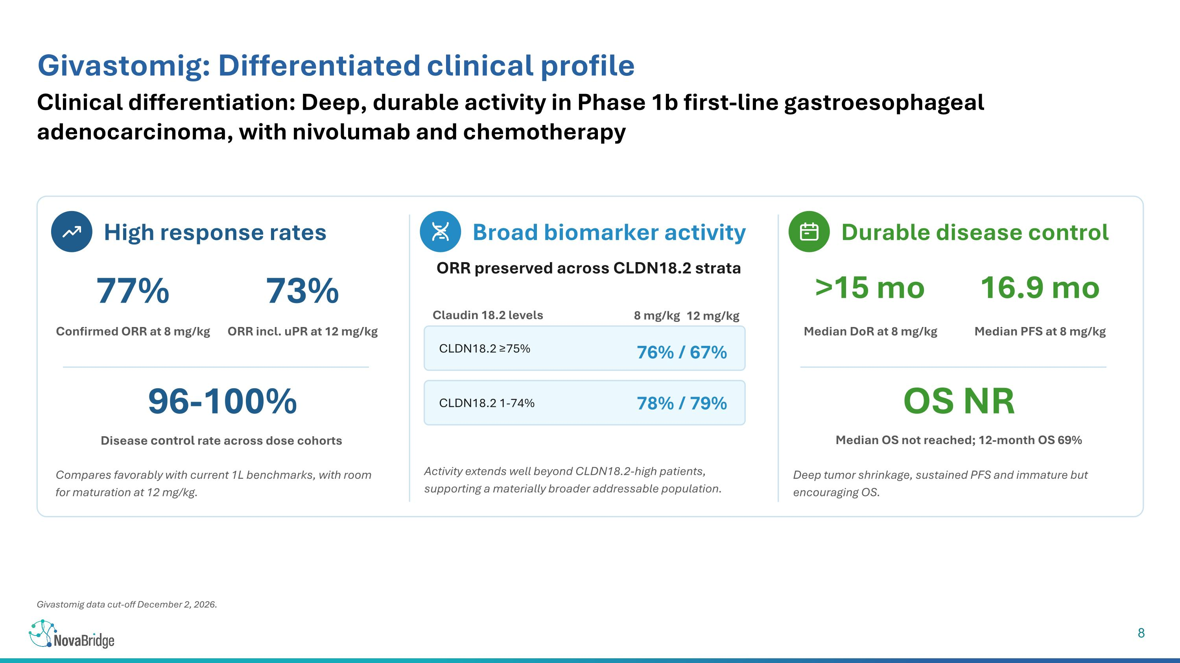
Clinical differentiation: Deep, durable activity in Phase 1b first-line gastroesophageal adenocarcinoma, with nivolumab and chemotherapy Givastomig: Differentiated clinical profile High response rates Broad biomarker activity Durable disease control 77% Confirmed ORR at 8 mg/kg 73% ORR incl. uPR at 12 mg/kg 96-100% Disease control rate across dose cohorts Compares favorably with current 1L benchmarks, with room for maturation at 12 mg/kg. ORR preserved across CLDN18.2 strata CLDN18.2 ≥75% 76% / 67% CLDN18.2 1-74% 78% / 79% Activity extends well beyond CLDN18.2-high patients, supporting a materially broader addressable population. >15 mo Median DoR at 8 mg/kg 16.9 mo Median PFS at 8 mg/kg OS NR Median OS not reached; 12-month OS 69% Deep tumor shrinkage, sustained PFS and immature but encouraging OS. Givastomig data cut-off December 2, 2026. Claudin 18.2 levels 8 mg/kg 12 mg/kg

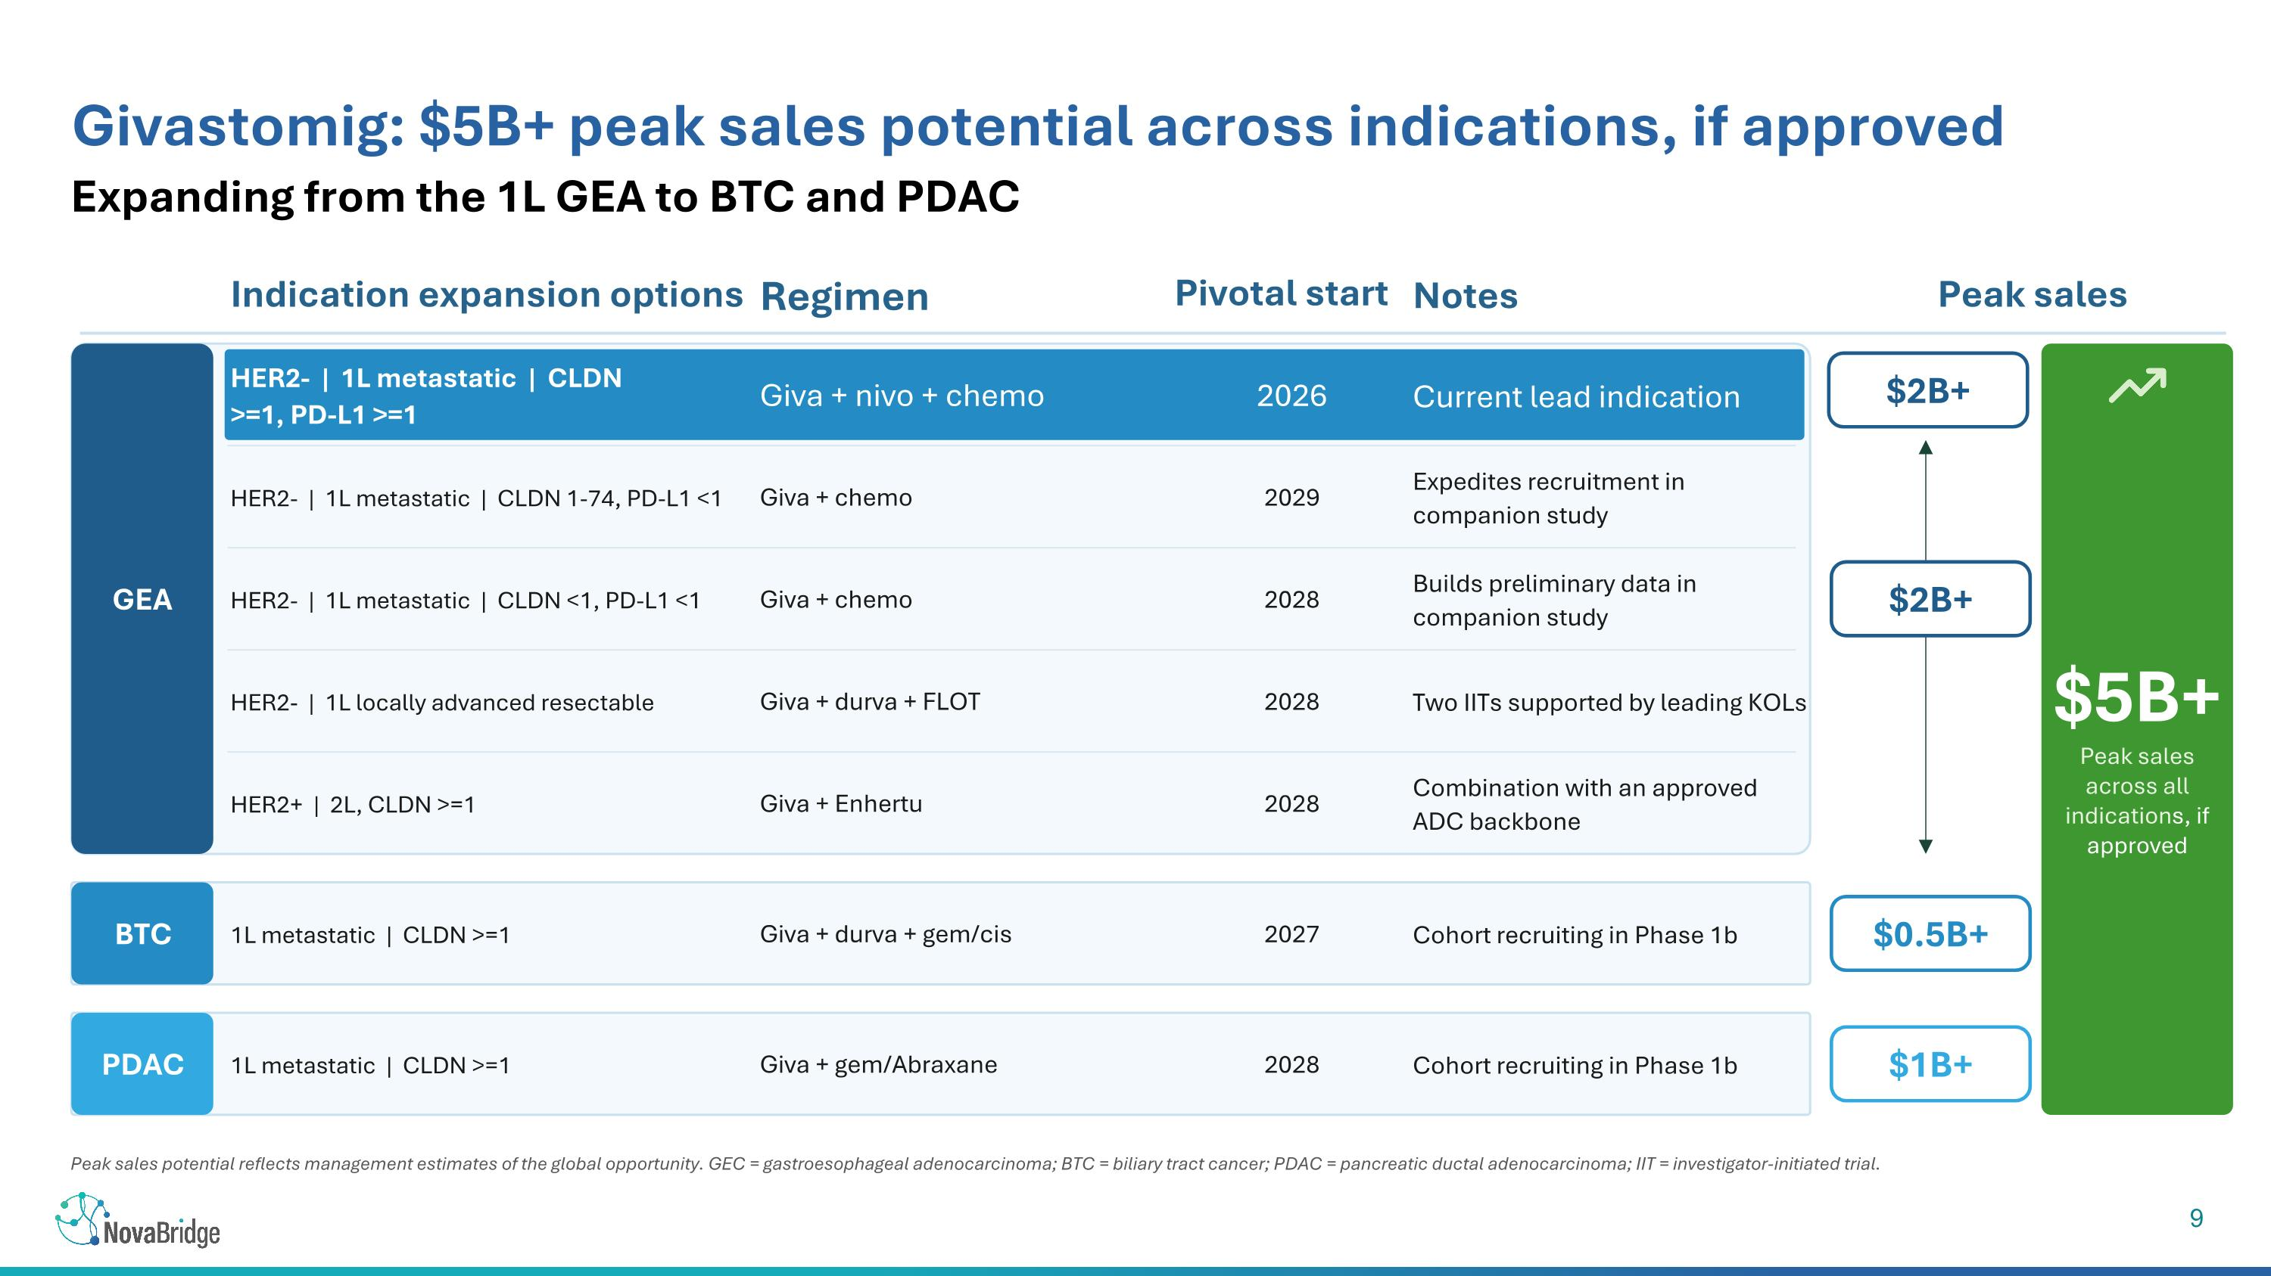
Peak sales potential reflects management estimates of the global opportunity. GEC = gastroesophageal adenocarcinoma; BTC = biliary tract cancer; PDAC = pancreatic ductal adenocarcinoma; IIT = investigator-initiated trial. Expanding from the 1L GEA to BTC and PDAC Givastomig: $5B+ peak sales potential across indications, if approved Indication expansion options Regimen Pivotal start Notes Peak sales GEA HER2- | 1L metastatic | CLDN >=1, PD-L1 >=1 Giva + nivo + chemo 2026 Current lead indication HER2- | 1L metastatic | CLDN 1-74, PD-L1 <1 Giva + chemo 2029 Expedites recruitment in companion study HER2- | 1L metastatic | CLDN <1, PD-L1 <1 Giva + chemo 2028 Builds preliminary data in companion study HER2- | 1L locally advanced resectable Giva + durva + FLOT 2028 Two IITs supported by leading KOLs HER2+ | 2L, CLDN >=1 Giva + Enhertu 2028 Combination with an approved ADC backbone $2B+ BTC 1L metastatic | CLDN >=1 Giva + durva + gem/cis 2027 Cohort recruiting in Phase 1b $0.5B+ PDAC 1L metastatic | CLDN >=1 Giva + gem/Abraxane 2028 Cohort recruiting in Phase 1b $1B+ $5B+ Peak sales across all indications, if approved $2B+

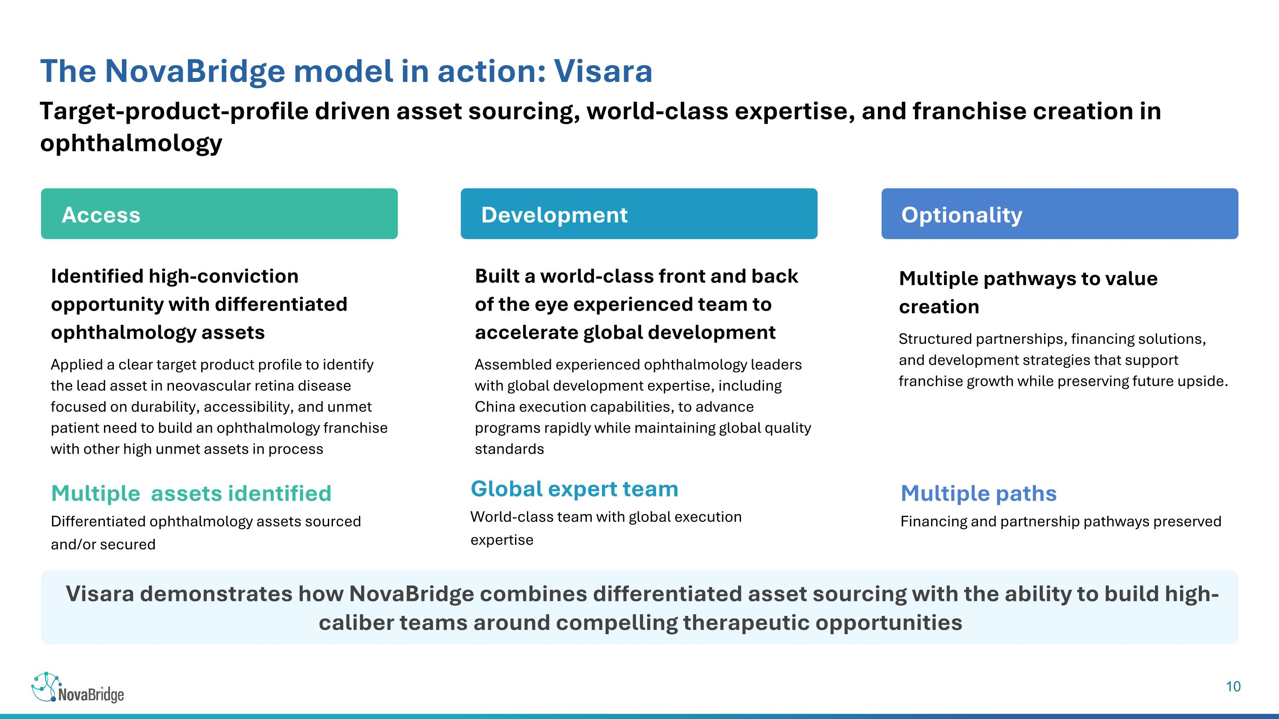
Target-product-profile driven asset sourcing, world-class expertise, and franchise creation in ophthalmology The NovaBridge model in action: Visara Identified high-conviction opportunity with differentiated ophthalmology assets Applied a clear target product profile to identify the lead asset in neovascular retina disease focused on durability, accessibility, and unmet patient need to build an ophthalmology franchise with other high unmet assets in process Built a world-class front and back of the eye experienced team to accelerate global development Assembled experienced ophthalmology leaders with global development expertise, including China execution capabilities, to advance programs rapidly while maintaining global quality standards Multiple pathways to value creation Structured partnerships, financing solutions, and development strategies that support franchise growth while preserving future upside. Multiple assets identified Differentiated ophthalmology assets sourced and/or secured Global expert team World-class team with global execution expertise Multiple paths Financing and partnership pathways preserved Visara demonstrates how NovaBridge combines differentiated asset sourcing with the ability to build high-caliber teams around compelling therapeutic opportunities Optionality Development Access

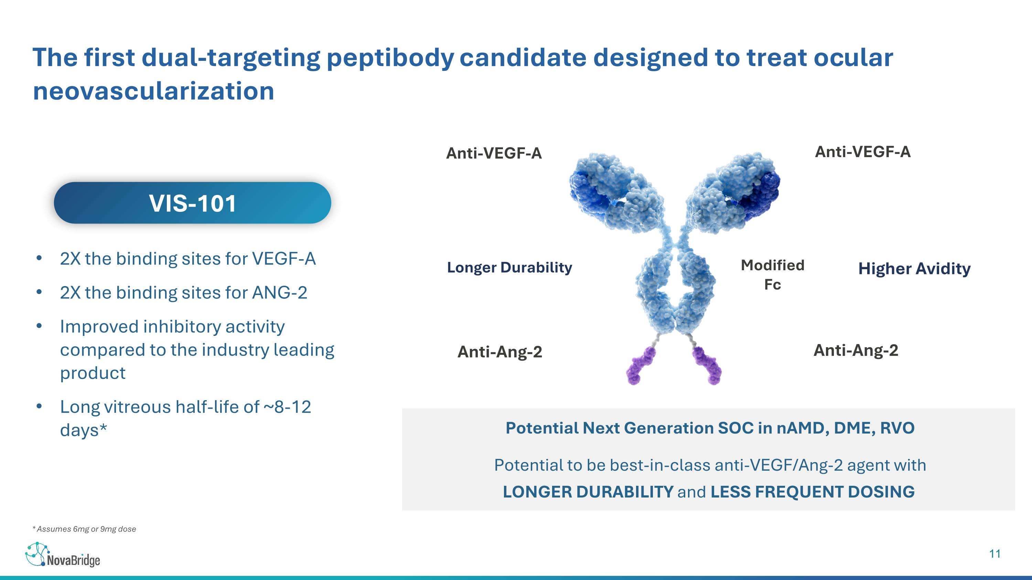
* Assumes 6mg or 9mg dose The first dual-targeting peptibody candidate designed to treat ocular neovascularization Potential Next Generation SOC in nAMD, DME, RVO Potential to be best-in-class anti-VEGF/Ang-2 agent with LONGER DURABILITY and LESS FREQUENT DOSING 2X the binding sites for VEGF-A 2X the binding sites for ANG-2 Improved inhibitory activity compared to the industry leading product Long vitreous half-life of ~8-12 days* VIS-101 Longer Durability Anti-VEGF-A Modified Fc Anti-Ang-2 Anti-Ang-2 Anti-VEGF-A Higher Avidity

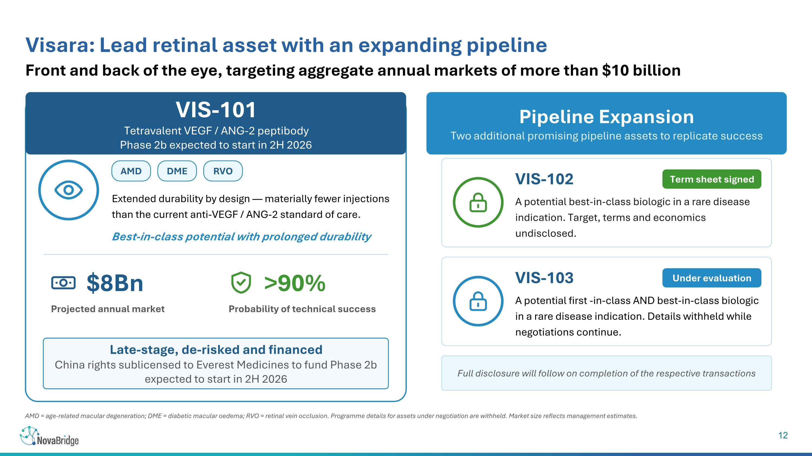
AMD = age-related macular degeneration; DME = diabetic macular oedema; RVO = retinal vein occlusion. Programme details for assets under negotiation are withheld. Market size reflects management estimates. Front and back of the eye, targeting aggregate annual markets of more than $10 billion Visara: Lead retinal asset with an expanding pipeline VIS-101 Tetravalent VEGF / ANG-2 peptibody ?Phase 2b expected to start in 2H 2026 AMD DME RVO Extended durability by design — materially fewer injections than the current anti-VEGF / ANG-2 standard of care. Best-in-class potential with prolonged durability $8Bn Projected annual market >90% Probability of technical success Late-stage, de-risked and financed China rights sublicensed to Everest Medicines to fund Phase 2b expected to start in 2H 2026 Pipeline Expansion Two additional promising pipeline assets to replicate success VIS-102 Term sheet signed A potential best-in-class biologic in a rare disease indication. Target, terms and economics undisclosed. VIS-103 Under evaluation A potential first -in-class AND best-in-class biologic in a rare disease indication. Details withheld while negotiations continue. Full disclosure will follow on completion of the respective transactions

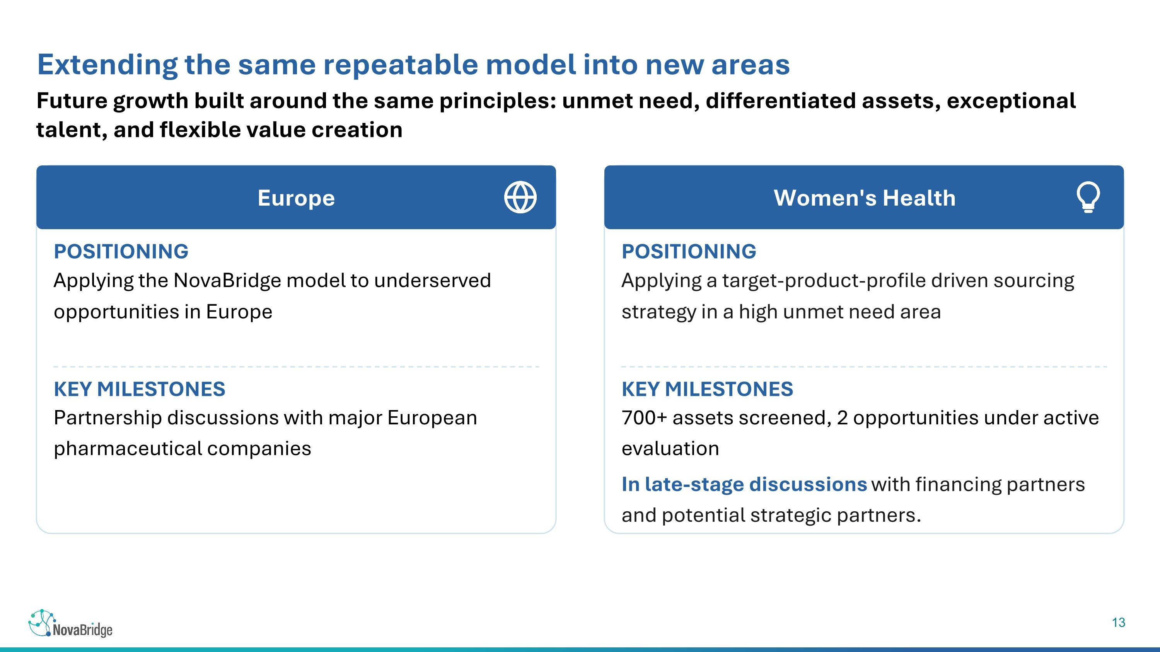
Future growth built around the same principles: unmet need, differentiated assets, exceptional talent, and flexible value creation Extending the same repeatable model into new areas Europe POSITIONING Applying the NovaBridge model to underserved opportunities in Europe KEY MILESTONES Partnership discussions with major European pharmaceutical companies Women's Health POSITIONING Applying a target-product-profile driven sourcing strategy in a high unmet need area KEY MILESTONES 700+ assets screened, 2 opportunities under active evaluation In late-stage discussions with financing partners and potential strategic partners.

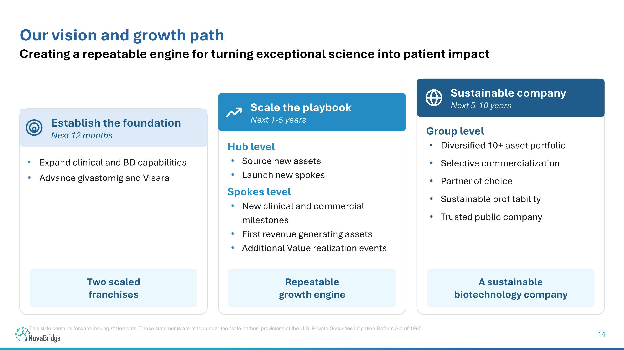
Creating a repeatable engine for turning exceptional science into patient impact Our vision and growth path Establish the foundation Next 12 months Two scaled franchises Scale the playbook Next 1-5 years Repeatable growth engine Sustainable company Next 5-10 years A sustainable biotechnology company Expand clinical and BD capabilities Advance givastomig and Visara Hub level Source new assets Launch new spokes Spokes level New clinical and commercial milestones First revenue generating assets Additional Value realization events Group level Diversified 10+ asset portfolio Selective commercialization Partner of choice Sustainable profitability Trusted public company This slide contains forward-looking statements. These statements are made under the “safe harbor” provisions of the U.S. Private Securities Litigation Reform Act of 1995.

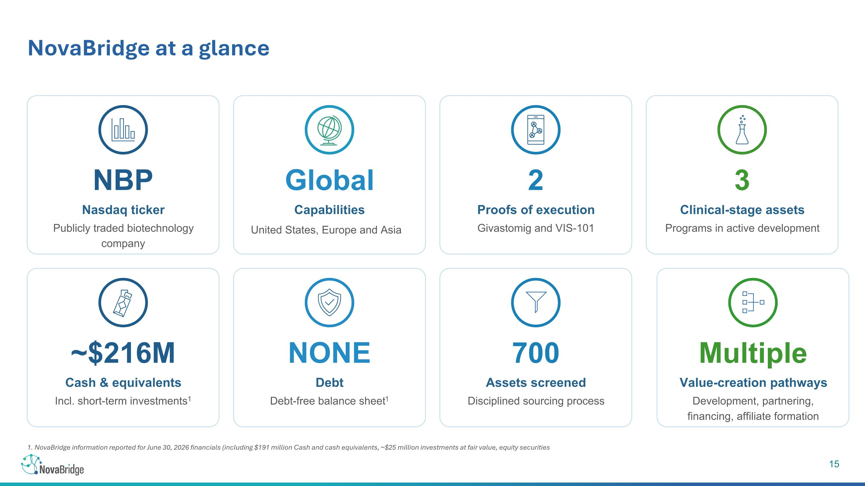
1. NovaBridge information reported for June 30, 2026 financials (including $191 million Cash and cash equivalents, ~$25 million investments at fair value, equity securities NovaBridge at a glance NBP Nasdaq ticker Publicly traded biotechnology company 2 Proofs of execution Givastomig and VIS-101 3 Clinical-stage assets Programs in active development ~$216M Cash & equivalents Incl. short-term investments1 NONE Debt Debt-free balance sheet1 700 Assets screened Disciplined sourcing process Global Capabilities Multiple Value-creation pathways Development, partnering, financing, affiliate formation United States, Europe and Asia

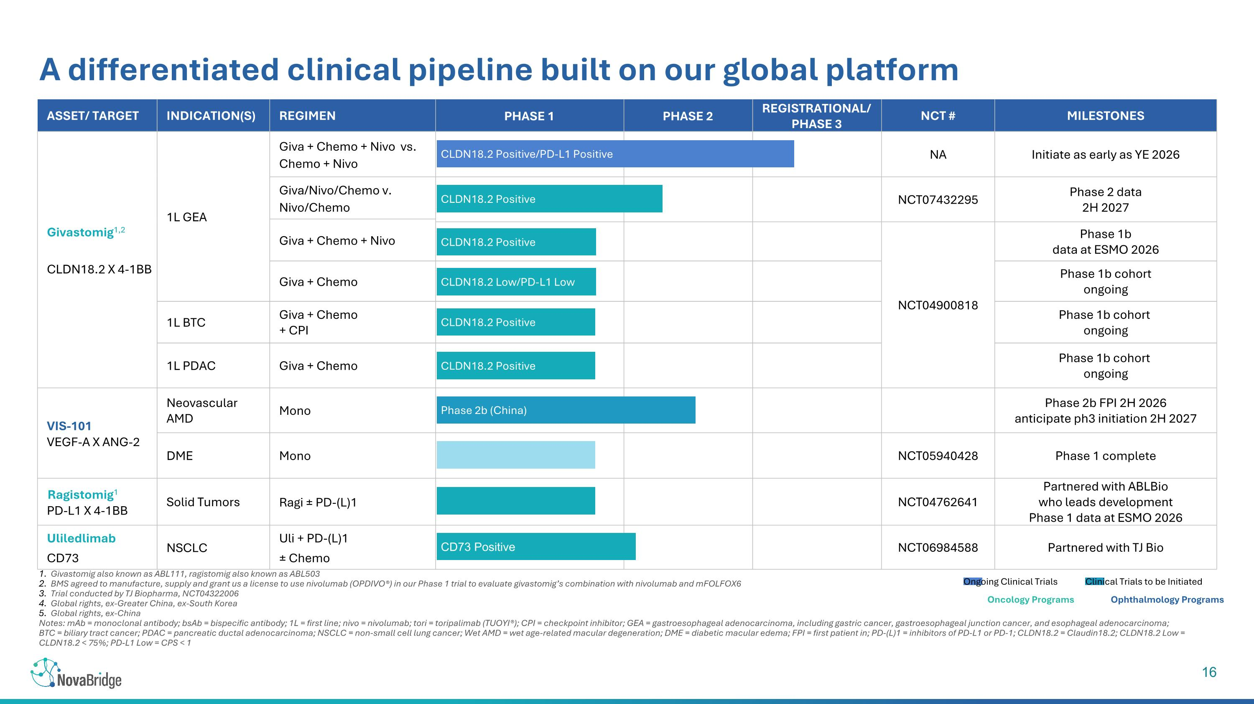
Givastomig also known as ABL111, ragistomig also known as ABL503 BMS agreed to manufacture, supply and grant us a license to use nivolumab (OPDIVO®) in our Phase 1 trial to evaluate givastomig’s combination with nivolumab and mFOLFOX6 Trial conducted by TJ Biopharma, NCT04322006 Global rights, ex-Greater China, ex-South Korea Global rights, ex-China Notes: mAb = monoclonal antibody; bsAb = bispecific antibody; 1L = first line; nivo = nivolumab; tori = toripalimab (TUOYI®); CPI = checkpoint inhibitor; GEA = gastroesophageal adenocarcinoma, including gastric cancer, gastroesophageal junction cancer, and esophageal adenocarcinoma; ?BTC = biliary tract cancer; PDAC = pancreatic ductal adenocarcinoma; NSCLC = non-small cell lung cancer; Wet AMD = wet age-related macular degeneration; DME = diabetic macular edema; FPI = first patient in; PD-(L)1 = inhibitors of PD-L1 or PD-1; CLDN18.2 = Claudin18.2; CLDN18.2 Low = CLDN18.2 < 75%; PD-L1 Low = CPS < 1 A differentiated clinical pipeline built on our global platform Asset/ Target Indication(s) Regimen PHASE 1 PHASE 2 REGISTRATIONAL/?PHASE 3 NCT # MILESTONES Givastomig1,2 CLDN18.2 X 4-1BB 1L GEA Giva + Chemo + Nivo vs. Chemo + Nivo NA Initiate as early as YE 2026 Giva/Nivo/Chemo v. Nivo/Chemo NCT07432295 Phase 2 data 2H 2027 Giva + Chemo + Nivo NCT04900818 Phase 1b data at ESMO 2026 Giva + Chemo Phase 1b cohort ongoing 1L BTC Giva + Chemo + CPI Phase 1b cohort ongoing 1L PDAC Giva + Chemo Phase 1b cohort ongoing VIS-101 VEGF-A X ANG-2 Neovascular AMD Mono Phase 2b FPI 2H 2026 anticipate ph3 initiation 2H 2027 DME Mono NCT05940428 Phase 1 complete Ragistomig1 PD-L1 X 4-1BB Solid Tumors Ragi ± PD-(L)1 NCT04762641 Partnered with ABLBio who leads development ?Phase 1 data at ESMO 2026 Uliledlimab CD73 NSCLC Uli + PD-(L)1 ± Chemo NCT06984588 Partnered with TJ Bio Ongoing Clinical Trials CLDN18.2 Positive/PD-L1 Positive CLDN18.2 Positive CLDN18.2 Positive CLDN18.2 Low/PD-L1 Low CLDN18.2 Positive CLDN18.2 Positive CD73 Positive Phase 2b (China) Clinical Trials to be Initiated Oncology Programs Ophthalmology Programs

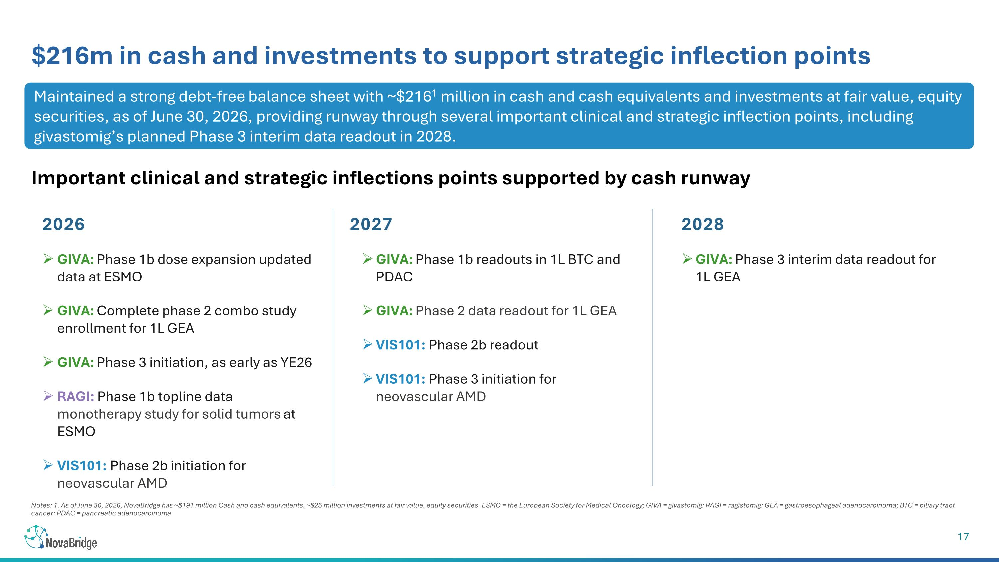
Notes: 1. As of June 30, 2026, NovaBridge has ~$191 million Cash and cash equivalents, ~$25 million investments at fair value, equity securities. ESMO = the European Society for Medical Oncology; GIVA = givastomig; RAGI = ragistomig; GEA = gastroesophageal adenocarcinoma; BTC = biliary tract cancer; PDAC = pancreatic adenocarcinoma $216m in cash and investments to support strategic inflection points 2027 2028 GIVA: Phase 1b dose expansion updated data at ESMO GIVA: Complete phase 2 combo study enrollment for 1L GEA GIVA: Phase 3 initiation, as early as YE26 RAGI: Phase 1b topline data monotherapy study for solid tumors at ESMO VIS101: Phase 2b initiation for neovascular AMD GIVA: Phase 3 interim data readout for 1L GEA GIVA: Phase 1b readouts in 1L BTC and PDAC GIVA: Phase 2 data readout for 1L GEA VIS101: Phase 2b readout VIS101: Phase 3 initiation for neovascular AMD 2026 Maintained a strong debt-free balance sheet with ~$2161 million in cash and cash equivalents and investments at fair value, equity securities, as of June 30, 2026, providing runway through several important clinical and strategic inflection points, including givastomig’s planned Phase 3 interim data readout in 2028. Important clinical and strategic inflections points supported by cash runway

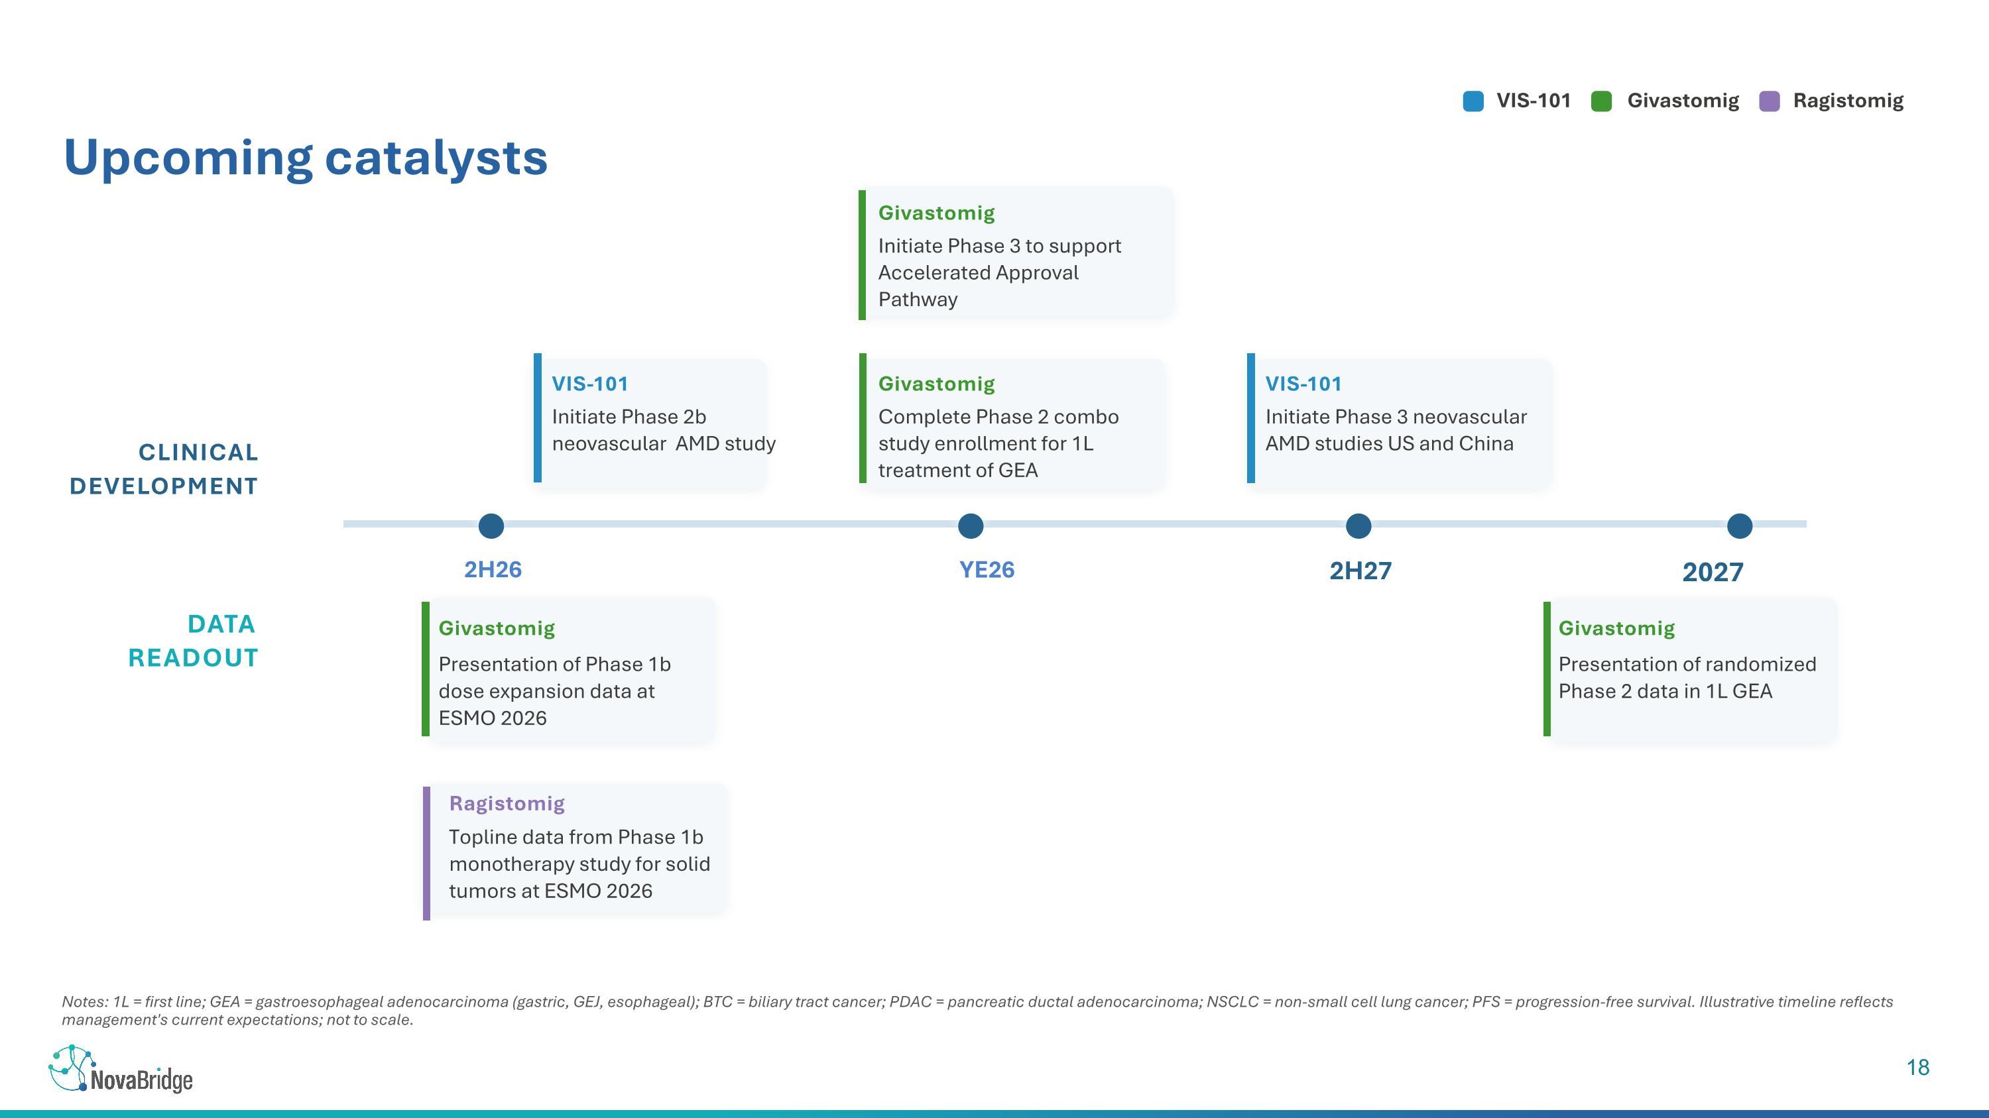
VIS-101 Givastomig Ragistomig CLINICAL DEVELOPMENT Givastomig Initiate Phase 3 to support Accelerated Approval Pathway VIS-101 Initiate Phase 2b ?neovascular AMD study 2H26 2H27 2027 Givastomig Complete Phase 2 combo study enrollment for 1L treatment of GEA Notes: 1L = first line; GEA = gastroesophageal adenocarcinoma (gastric, GEJ, esophageal); BTC = biliary tract cancer; PDAC = pancreatic ductal adenocarcinoma; NSCLC = non-small cell lung cancer; PFS = progression-free survival. Illustrative timeline reflects management's current expectations; not to scale. Upcoming catalysts YE26 VIS-101 Initiate Phase 3 neovascular AMD studies US and China DATA READOUT Givastomig Presentation of Phase 1b dose expansion data at ESMO 2026 Givastomig Presentation of randomized Phase 2 data in 1L GEA Ragistomig Topline data from Phase 1b monotherapy study for solid tumors at ESMO 2026


Thank you www.novabridge.com IR@novabridge.com

